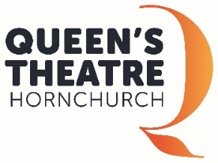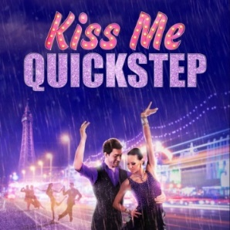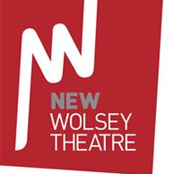

Would you like the chance to be part of a production at
The New Wolsey Theatre?

We are on the lookout for local Ballroom Dancers to feature in our upcoming production of Kiss Me Quickstep in Spring 2019!

Read on for more information.....

The New Wolsey Theatre, Ipswich is looking for local community ballroom dancers (ages 16+) to join our production.
About the Show: Kiss Me Quickstep is a sequin-studded warm-hearted ballroom drama by Amanda Whittington, produced by Queen’s Theatre Hornchurch and New Wolsey Theatre Ipswich. Three young couples are striving for glory on the competitive dance circuit – having finally made it to Blackpool’s National Amateur Championships via the motorway hard shoulder. This bittersweet comedy reveals the backstage stories behind the fabulous frocks, fixed smiles and fake tan, looking at the real lives of those for whom dancing is everything.
The Community Ballroom Dancers will feature in sequences throughout the production as the other competitors. Dance styles will include the jive, cha-cha, samba, foxtrot, and waltz.
You will have to audition to take part but you do not need to have any previous theatre experience.
Audition: Saturday 19th January 2019, 3.45pm - 5pm at the High Street Exhibition Gallery (next to the museum), High Street, Ipswich, IP1 3QH.

This is an opportunity to meet our choreographer and audition as part of a group with other dancers.

If you are unable to attend this audition but would like to be considered please us a video clip of your Ballroom and/or Latin dancing.

If you can attend the audition please let us know by emailing: Rachel Fitzgerald, Creative learning Administrator at RFitzgerald@wolseytheatre.co.uk or call 01473 295930
Rehearsals: Selected evening dates in Ipswich over the period 04 February – 09 March 2019. Video footage of routines to learn will be provided to you, so you can practice in your own sessions.
Saturday 2nd March - A rehearsal on set in Hornchurch with the choreographer and a free opportunity to see the show performed there. Transport from Ipswich to Hornchurch will be provided.
Technical / Dress Rehearsals: Evenings of Monday 11 & Tuesday 12 March 2019 in Ipswich.
Performances: 13 March – 23 March 2019 in Ipswich.
Please note this is a voluntary opportunity for non-professional community dancers and is not classed by Equity as a professional engagement. New Wolsey Theatre will reimburse Community Dancers for their travel during the performances.

