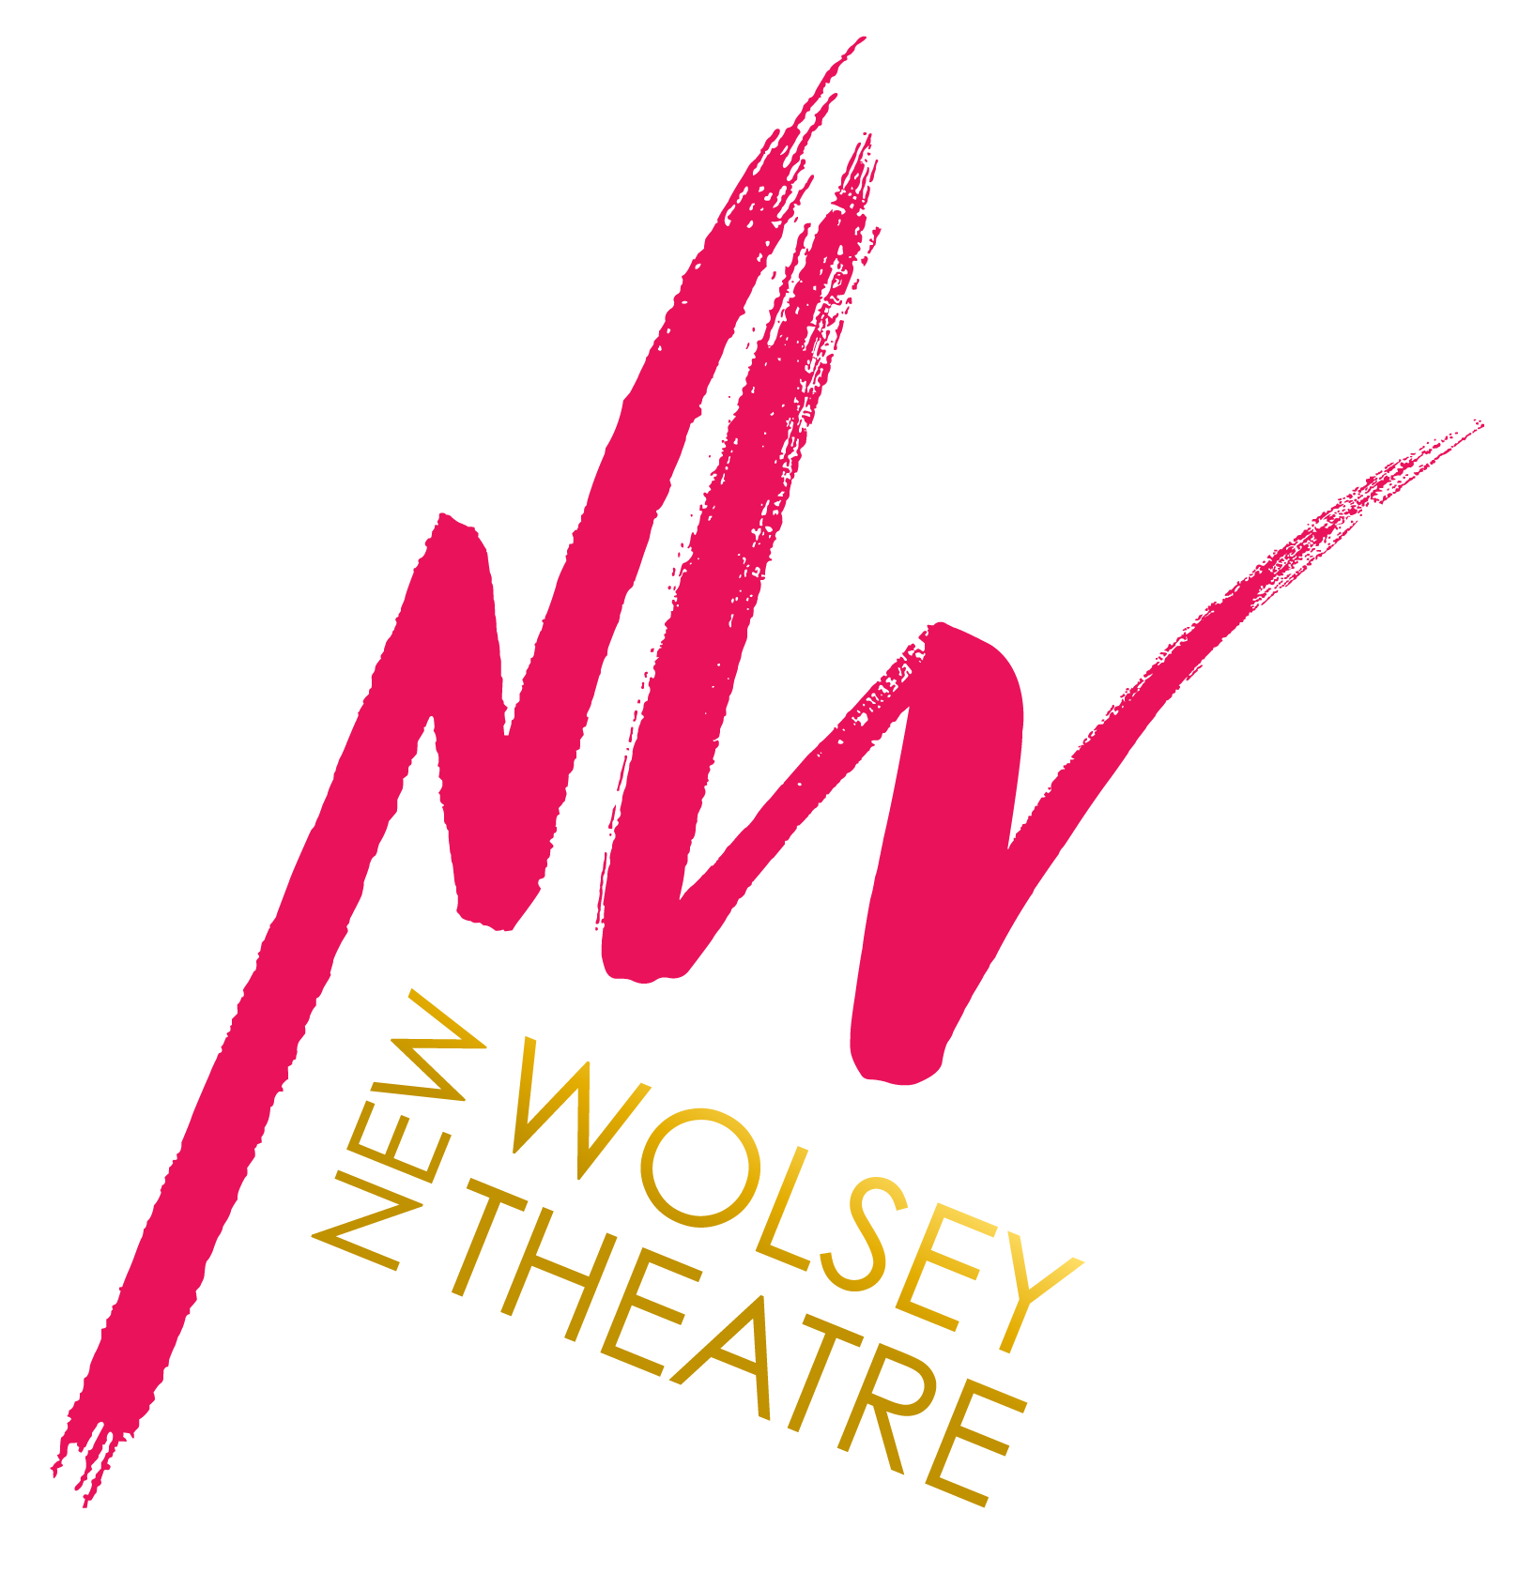
CONFIDENTIAL

Completed applications should be returned to: Julie French jfrench@wolseytheatre.co.uk

PLEASE COMPLETE THIS FORM IN TYPE OR BLACK INK

APPLICATION FOR THE ROLE OF:

PERSONAL DETAILS

First Name(s):
Surname:
Address:
Postcode:
Tel:
Mobile:
e-mail:

Eligibility to work in the UK

We are legally obliged to ask you to provide evidence of your right to work in the UK. If you are successful with your application we will ask you to provide appropriate documents, such as your passport, visa, work permit or birth certificate and proof of your national insurance number, in accordance with the Asylum and Immigration Act 1996.

Are you legally authorised to work in the UK? Yes No

Is this subject to a work permit or visa? Yes No

EDUCATION, TRAINING AND QUALIFICATIONS SUMMARY
(A concise CV containing this information may be submitted instead of completing this section)

School / College / University | From | To | Qualification(s) Received

EMPLOYMENT HISTORY (SUMMARY)
(A concise CV containing this information may be submitted instead of completing this section)

Company name | From | To | Title

With clear reference to the Person Specification, explain why you wish to apply for the post and describe the skills and experience you have to undertake the job as outlined.
This is your opportunity to convince us that you are the right person for the job. (Continue on a separate sheet if necessary.)

MISCELLANEOUS

As an organisation accredited by the Job Centre as a Disability Confident Employer, we guarantee to interview all disabled applicants who meet the essential criteria for this vacancy.

The New Wolsey Theatre wishes to encourage applications from suitably qualified and experienced deaf and disabled people and we therefore ask you to use the space below to provide information on your disability status and access requirements if you wish to be considered in line with the above scheme (please mark as N/A if not applicable or leave blank if you wish not to declare).

This information will remain confidential and is required to help us fulfil our responsibility to encourage and assist in the employment of deaf and disabled people.

The NWT will facilitate any Access To Work claims if appropriate, and will cover access costs, including any access requirements to attend interviews.

provided.

Disability Status and Access Requirements:
Do you have a current driving licence? |  | Yes / No
Do you have your own transport? |  | Yes / No
Are you at least 18 years of age? |  | Yes / No
If offered this position will you continue to work in any other capacity? |  | Yes / No
(If yes, please give details)
When are you available to start?
Where did you find out about this opportunity?
e.g. Indeed, Arts Jobs, Facebook, etc.
Please tell us the best way to be contacted or to receive information in regards to your application e.g. E-mail, telephone etc.
Equal Opportunities and Equality, Diversity and Inclusion monitoring | Please complete and our Equality, Diversity and Inclusion Monitoring Form (clicking the link will open up a google form)

ANY OTHER INFORMATION
Please use this space to tell us about anything else that may be of relevance to your application.

REFERENCES
Please give details of two referees.

Name:
Company:
Position:
Relationship to applicant:
Address:
Postcode:
Tel:
e-mail:

Name:
Company:
Position:
Relationship to applicant:
Address:
Postcode:
Tel:
e-mail:

References may be taken up before interview or prior to an offer being made.
If you would prefer that we did not take references until after an offer has been made please tick here □

Declaration

I have read and understood the information contained in this application form, and I declare that all information I have provided on this form, or in an attached CV, is true and accurate. I understand that omissions or incorrect statements might disqualify me from this position and, if already appointed, my employment may be terminated. I also understand that any offer of employment is subject to satisfactory references.

By signing this form, I understand I am agreeing to the above declaration:

Signed:
Print Name:
Date:

