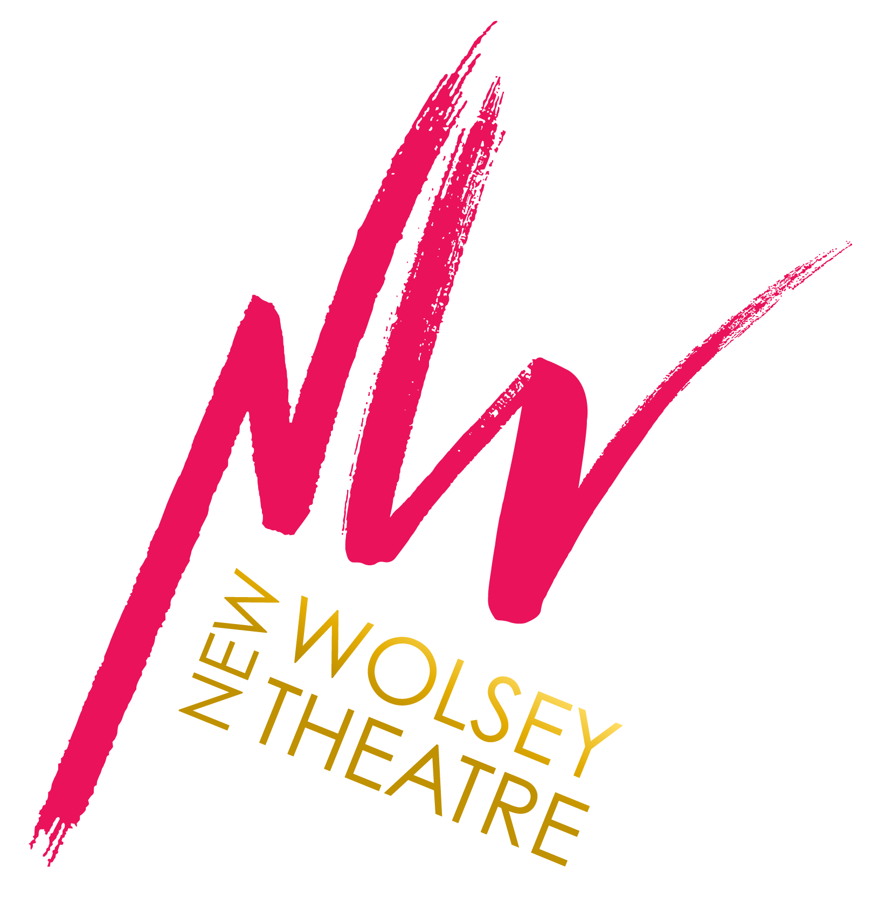
September 2021
Dear Applicant,

Thank you for your interest in the position of Creative Communities Administrative Assistant (Kickstart Placement) at the New Wolsey Theatre.

If you are organised and love a varied working week, you could be a great match for this role. The Creative Communities Administrative Assistant will work alongside the Creative Communities team contributing to the day-to-day administration of the department, including practical, logistical and administrative support to a variety of regular and one off projects and workshops.

The Creative Communities Administrative Assistant will work across all strands of the Creative Communities programme including Youth Theatres, Schools and Community settings, and will be supported to develop their skills as an administrative assistant and project co-ordinator.

You will be an advocate for all the departments’ activities and you will work with colleagues across the New Wolsey Theatre. You will be organised and methodical, as your week might include preparing contracts and planning activity with colleagues, setting up for workshops or gathering data for long term planning. You will be a good communicator, acting as the first point of contact for the department (answering the phone!). This role is one that provides the oil for the smooth running of many moving parts. You do not need to be someone that takes centre-stage all the time but you do need to be confident in handling people with integrity and warmth. You’ll have oodles of common sense and you’ll be a detailed planner to make sure the programme of activity runs smoothly. You’ll be joining the New Wolsey Theatre at an exciting time; we are opening our brand new participation space, NW2 and welcoming participants back after lockdown. The Creative Communities Team will welcome you with lots of support to ensure you can quickly settle in and be effective in this 6 months placement. If this sounds like you, we can’t wait to meet you..

We are an ambitious producing and receiving theatre, with a national reputation for its work in access and inclusion, and for the production of new musical theatre. Our annual Rock’ n’ Roll Panto, written and directed by Artistic Director Peter Rowe, is much loved by local audiences and is the cornerstone of our annual programming.

We’re extremely proud of our outreach and participation work, which in October 2020 moved in to our new participation space NW2. In 2020 we also undertook an extensive renovation and refurbishment programme for our main building, resulting in a transformed cafe/ bar area, more toilets and improved auditorium seating.

You don’t necessarily have to be a ‘theatre person’ to do well at the New Wolsey Theatre. We welcome people from all backgrounds and we’re actively trying to ensure that our workforce is diverse. By this, we mean that we want to employ people from a wide range of backgrounds, ethnicities, ages, gender identities, disabilities, class (socio-economic backgrounds) and so on. This isn’t because we want to tick a box that says ‘diverse’ but because we genuinely believe that our business will be much improved by having a real range of people working (and volunteering) within it.

So, if you haven’t considered working for a theatre before, maybe now’s the time to check us out. We’re super-friendly, hard working and love meeting a challenge. If that sounds like you, and you think you might have the skills/ experience for the role (wherever you gained them) come and talk to us. We can’t wait to meet you!

Yours warmly,
From Sarah Homes, Chief Executive

Eligibility

Current eligibility criteria for Kickstart applicants:
- Aged 16-24
- Claiming Universal Credit
- In receipt of no other earned income

How to apply

Talk to your Work Coach at Job Centre Plus about being referred to apply for this placement.

Applicants who have been referred via their Work Coach must complete our Application Form and Equality, Diversity and Inclusion Monitoring Form

Please note, we do not accept CVs as a form of application, however you may submit a concise CV containing your education, training and qualifications and employment history instead of completing this section of the application form.

If you need us to make any adjustments to allow you to fully participate in this application and selection process please get in touch with Lucy Parker lparker@wolseytheatre.co.uk or 01473 295940.

However you choose to apply, you will need to tell us about your education, training, qualifications, and employment history, as well as to consider the following questions:

- Why are you interested in being our Creative Communities Administrative Assistant?
- How do your skills and experience make you the best person to be our Creative Communities Administrative Assistant?

Please read through the Job Description, Job Specification and Person Specification before applying for this role, these can be found further down this document.

If you would like an informal chat with someone about the role, please email our Head of Creative Communities, Tony Casement tcasement@wolseytheatre.co.uk

Completed applications should be returned to Julie French jfrench@wolseytheatre.co.uk

As an organisation accredited by the Job Centre as a Disability Confident Employer, we guarantee to interview all deaf and disabled applicants who meet the essential criteria for this vacancy.

We will facilitate any Access To Work claims if appropriate, and any access costs will be covered up front including any access required for attending interviews.

Key Dates

Application Deadline 10am on Tuesday 26th October 2021
Interviews Tuesday 2nd November 2021
Role start date November- depending on candidate

Equal Opportunities

The mission of the New Wolsey Theatre is to create, develop and produce a vital and dynamic programme of performances and participatory activity for the people of Suffolk and surrounding areas. It aims to create a programme of the highest quality, maximum diversity and greatest possible accessibility. We believe that this is best achieved through the implementation of an Equal Opportunities and Diversity Policy informing all areas of the company’s activity and employment practice.

We are committed to ensuring equality and fairness for all employees, collaborators, contractors and the general public. We will not discriminate on grounds of gender, marital status, race, ethnic origin, colour, nationality, national origin, disability, sexual orientation, gender reassignment, religion or age. The New Wolsey Theatre opposes all forms of unlawful and unfair discrimination and will work to promote opportunities for sections of the community that are currently under-represented.

All individuals will be treated fairly and with respect. Selection for employment, promotion, training or any other benefit will be on the basis of aptitude and ability. All employees will be helped and encouraged to develop their full potential and the talents and resources of the workforce will be fully utilised to maximise the organisation’s output.

We strive to create an environment in which individual differences and the contributions of all our staff are recognised and valued. No form of intimidation, bullying or harassment will be tolerated.

We actively encourage applications from people of all backgrounds, especially those currently less represented in our industry and on our stages. We are particularly interested to receive applications for this role from people who identify as deaf and disabled people, and neurodiverse people.

We are happy to make all reasonable adjustments to enable applicants to participate in the selection process, and for the successful applicant to carry out their role.

We will regularly review our employment practices and procedures to ensure fairness. This policy has the approval of the Board and will be reviewed on an annual basis.

More Information About The New Wolsey Theatre

We are a company that really cares about what we do, who we work with, and what we’re working for. Most of the time we put on plays. But we also serve tea and coffee for our guests, offer them lunch and somewhere comfortable to sit and have a chat and sometimes we present music, comedy, dance or even circus. We invite children to come and play with us, sometimes with their parents too. Teenagers come and work with us in our Youth Theatre Groups – in 2021 we’re doing this online for the first time. Schools ask us to go and visit to tell stories, make performances, or teach skills, and sometimes they come to us to do those things. Schools love coming to see our annual Rock ‘n’ Roll pantomime – in a normal year we’ll do over 90 performances of our Panto between November and January. In 2020 we staged The Snow Queen, which was our first live and livestreamed show. It received 5 star reviews and did really well, even though it was just 12 performances.

By ‘us’ we don’t just mean the permanent staff that are employed by us. We rely on volunteers, casual and freelance staff to keep the wheels turning. Of course, they haven’t turned much in the last year, but we’ll be getting the show back on the road in 2021 and we’ll need people in all those roles once we’re fully open. We’ll also need great writers, actors, directors, designers and technicians, which is why we run talent development programmes like Testing Ground. We take the lead in our industry sometimes, to make change, as we did in setting up Ramps On The Moon

The New Wolsey Theatre plays an active role in the business scene of Ipswich and is central to the creative life of Suffolk. We regularly talk to other cultural organisations and community groups, such as, UnScene Suffolk, Suffolk Refugee Support, Trinity YMCA, Roma Support, Suffolk Artlink, Volunteering Matters, Suffolk Guide Association to name but a few. We’re supported by the local council and the county council, as well as Arts Council England because of the range of work we do. You may also be interested to know that we’re a registered Charity.

If you’d like to know more about the New Wolsey Theatre, we recommend that you use our website (which you’ll notice needs updating– we’re working on that right now) and that you do your own research. Be curious about us and see what you can find out; it will probably help you with your application. The New Wolsey Theatre is going through a period of great change, some of which is because of Covid-19 and some of which was going to happen anyway. We won’t be doing everything the way we’ve done it before. We’re innovating and adapting like never before, so we’re open to doing things differently. Come and be part of that.

JOB DESCRIPTION

Job Title: Creative Communities Administrative Assistant (Kickstart Placement)

Responsible to: Creative Communities Manager

Job Purpose: To support the Creative Communities Department in the day-to-day administration of the department, including practical, logistical and administrative support to a variety of regular and one off projects and workshops.

The Creative Communities Administrative Assistant will work across all strands of the Creative Communities programme including Youth Theatres, Schools and Community settings, and will be supported to develop their skills as an administrative assistant and project co-ordinator.

Key Responsibilities:

Administration:

- To support the planning and administration of the Creative Communities Department’s activities with schools, community groups and participants.
- Input data into the Department’s finance system.
- Work with the Creative Communities Manager to prepare project agreements between the Creative Communities Department, schools and outside organisations.
- To support the collection of monitoring data and the dissemination of statistics.

Communication:
- To act as the first point of contact between the New Wolsey’s Creative Communities Department and members of the public; participants; freelance practitioners; schools and outside organisations.
- Contribute to the Department’s social media output.
- To act as an advocate for the work of the Creative Communities Department
- To work with the Creative Communities and Communications Departments to promote the Creative Communities offer to the general public.

Equality and Diversity

- To work closely with colleagues across the organisation to ensure the New Wolsey Theatre is an accessible place to visit and work, including online experiences.
- To contribute to the New Wolsey Theatre’s ambitions and programmes of equality, diversity and inclusion, its Agent for Change programme and The Ramps on the Moon project

Other Responsibilities
- Ensure compliance at all times with the theatre’s Equal Opportunities, Safeguarding and Health & Safety policies and practices (training will be provided).
- To actively engage with participants and parents/carers/teachers, where applicable, and the wider New Wolsey Theatre staff team.
- Be responsible for ensuring the Front of House areas of NW2 are kept tidy and supplied.
- Promote effective communication and working relationships between the Creative Communities Department and other Departments of the New Wolsey.
- Support the delivery of all Creative Communities activity, on and off site, where appropriate.
- To gather any materials required for projects/workshops in advance, where appropriate.
- To support the organisation and supervision of group visits to relevant live performance events at The New Wolsey Theatre.
- To undertake unlocking and locking-up duties of workshop/office spaces as required.
- To be an excellent role model to young people.
- To attend and contribute to supervision, planning, and evaluation meetings as required.
- To attend continuing professional development opportunities, as required.
- To undertake any other duties as reasonably required.
September 2021

This job description is a guide to the nature of the work required of this position. It is neither wholly comprehensive nor restrictive.

We are happy to talk with individuals about reasonable adjustments required to carry out a role.

NOTE:
An enhanced DBS check will be sought from the successful applicant: the candidate should be in no way unsuitable to work with children, young people and vulnerable adults.

Having a criminal conviction does not necessarily stop you from being able to apply, It is important that there is an opportunity for applicants to provide the circumstances and context around any convictions declared. We will only consider convictions and cautions that are specifically relevant to the position being appointed to as important.

JOB SPECIFICATION

Contract
Kickstart Placement- 6 months Fixed Term Contract

Salary
£9.75 per hour. An additional x 0.5 of your hourly rate will be paid if you are required to work on a Sunday or Bank Holiday.

Hours
25 hours per week.

Please note that additional hours may be required depending on the performance schedule, staff sickness and annual leave. Any overtime is to be taken as time off in lieu by arrangement with your line manager.

Working patterns will vary dependant on activity for that week. Due to the nature of the role, you will be required to work some evenings and weekends

We always aim for staff to take two full days off a week however this may not always be possible due to the operational needs of the theatre.

Annual Leave Entitlement
The standard Annual Leave Entitlement is the statutory minimum of 5.6 weeks per year, which equates to 28 days per year for full time staff working a 5 day week. This role’s Annual Leave Entitlement will be pro rata, based on 25 hours a week. You will be expected to take statutory bank holidays as part of your annual entitlement unless you are required to work on a particular bank holiday or have agreement from your Line Manager to do so. Annual leave requests have to be submitted to your line manager for authorisation. It is suggested that the majority of annual leave is taken during the summer months when the theatre has no performances scheduled. There will be certain times of the year when annual leave cannot be taken because of the work of the organisation.

.

PERSON SPECIFICATION

Qualifications, Experience and Competencies

Essential:

- Experience of working in an administration role (this can be through paid work or voluntary e.g. through education or clubs)
- Capable of using a computer with some experience of Microsoft Office programmes (Outlook, Word or Excel)
- Good written and spoken English
- Ability to work flexibly with occasional evening and weekend work.

Desirable:

- An interest in the arts
- Planning and multi-tasking skills
- Evidence of ability to handle admin tasks with attention to detail and accuracy
- Experience of working with children, young people and/or vulnerable adults.
- Experience of working with diverse communities.
- Experience of project co-ordination.
- Working knowledge of Microsoft Office (Outlook, Word, Excel)
- 3 GCSEs at grade 4 or above, or NVQ level 2 (or equivalent qualification or experience)
- An understanding of equality, diversity and inclusion.

Key Qualities

Essential

- Able to work well within a fast-pace environment, with the ability to effectively respond to instructions, contribute ideas and support other team members.
- Organised, motivated and disciplined.
- Able to respond receptively to new ideas and initiatives, responding to creative problems with creative solutions
- Able to work under pressure and manage competing deadlines.
- Excellent interpersonal skills with the ability to communicate effectively with individuals at all levels.
- Enthusiastic with a good sense of humour, a positive outlook, and a ‘can-do’ approach.

